CURRICULUM VITAE  SURNAME Loaiza Usuga  FIRST NAMES Juan Carlos  Full professor Universidad Nacional de Colombia  Permanently invited Professor University of Cracow  Accredited Full professor in Spain | 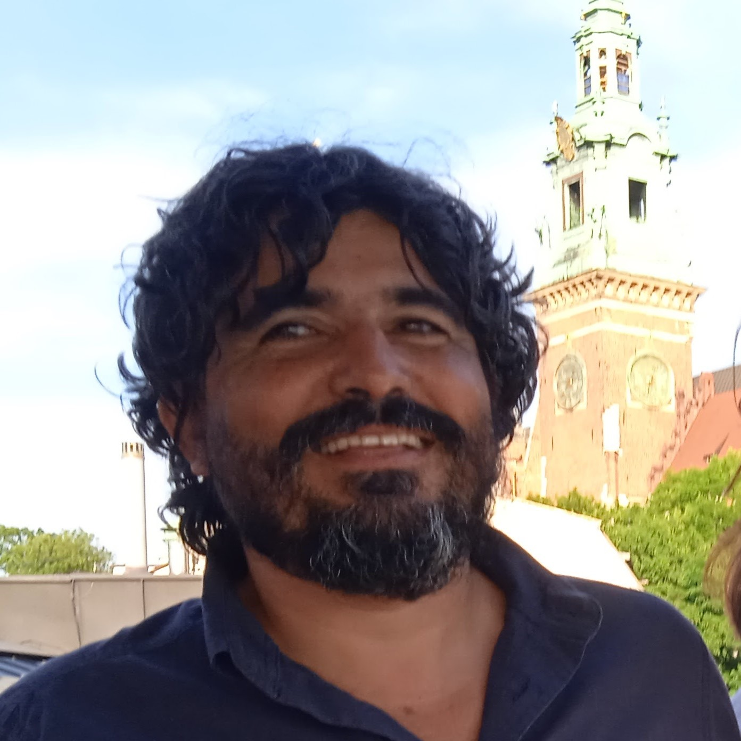
Email jcloaiza@unal.edu.co
ORCID: https://orcid.org/0000-0002-3821-7518

EDUCATION
Postdoc Soil Micromorphology. (University of Agriculture in Krakow, 2021) – Poland
Postdoc Geoarchaeology. AmbiLab (La Laguna University, 2019) - Spain
European PhD. in Environment and Soil Sciences (Lleida University, 2007) – Spain
Postgraduate degree in Soil Micromorphology (Barcelona University and Ghent University, 2005) – Spain /Belgium
MSc in Edaphology and soil chemistry (Lleida University, 2004) – Spain

CV SUMMARIZED

Professor Juan Carlos Loaiza is full professor at the Universidad Nacional de Colombia since 2010 and permanent invited professor at Cracow University since 2018, teaching Geomorphology, Soil survey, soil micromorphology, soil genesis and classification, ecopedology and soil sciences oriented to agronomy and environmental sciences in tropical environments.
Professor Juan Carlos Loaiza’s research focuses on soil physics, soil micromorphology and catchment hydrology related to human management and its effects as landslides and natural hazards. Specifically, he has been working on issues of environmental effects of erosion processes, gold and coal Minnery impact, land use land change associated to agricultural dynamics using techniques of micromorphology, hydrological monitoring catchments with continuous measurements and geophysical techniques. Its knowledge on soil genesis and soil classification in tropical environments is key to understand and better estimating the impact and extent of the natural processes and its impacts associated to soil sciences. Another subject that has been from interest of Dr. Loaiza is the geoarchaeology participating in numerous archaeological projects on Prehispanic and Colonial periods in Colombia and Neolithic archaeological campaigns in the south of Spain.

Additionally, he has been professor at Meknes university in Morocco, Universidad del Altiplano (Peru), Lleida University and La Laguna University in Spain. Author of 36 peer-reviewed scientific papers related to soil conservation, soil micromorphology, soil physics, geoarchaeology and soil sciences in tropical environments. Author of 20 book chapters published in European and American editorials. He was editor and author of books entitled “Manual of Micromorphology and complementary technics” awarded as best soil sciences publication in Latin America by the Latin American Soil Sciences society in 2018, Landslides, and tropical soil management books.

His research connections and collaborations with Europe started in 2000 in Spain at the Lleida University, working there during six years and particularly in Poland started on 2016 teaching annually soil sciences, some of the time being part of the Erasmus mundus program. Professor Loaiza is member of the Polish Society of Soil Sciences (PSSS), participating to the congresses and trips organized by the society and with continuous research projects on soil sciences. Professor Loaiza has organized congresses related with soil sciences in tropical environments focused on soil world micromorphology conference and the Latin American micromorphology school by the International Union of Soil Sciences (IUSS). Session VIII. Invited of micropaleopedology congresses since nowadays, one of the most relevant was director of the International Soil Conservation Organization (ISCO) 2013-2015 being since now part of the Board of directors of the ISCO. He had director of ELAFIS XI (Latin American School of Soil Physics), worked as editor of 11 scientific journals related with soil sciences in Latin America, member of FAO Intergovernmental Technical Panel on Soils of the Global Soil Partnership, International Network of Salt-affected Soils and World Soil Resources Report working group.

